

PROJECT REPORT (Aug (2023) – Jan (2024))

Online Market place for Handmade Crafts.

SUBMITTED BY

* Ashish Kumar Dey (12301661) Roll no: RK23FSA31
* Herman Magayane (12321996) Roll no: RK23FSA28
* Nandini Sharma (12306734) Roll no: RK23FSA32
* Peeyush Maurya (12305810) Roll no: RK23FSA30

Course code: CSE 326

Under the Guidance of

Mr. Muhammed Rafeeq War (30648)

Website Link: <https://github.com/Peeyush-04/Japan-Crafts>

Source code:

Code will be available in the provided link of GitHub.

School of computer science and engineering

PROJECT REPORT

TOPIC - Online Market place for Handmade Crafts.

1. INTRODUCTION

Japan Crafts is a website for everything handmade in Japan. It’s a space where one can appreciate many original and authentic objects in Japan showing Japanese skilfulness and taste. Feel free to click on any of the gift/souvenir category or treat yourself with one. The site has an extensive array of different types of Japanese arts and handicrafts ranging from pottery, woodwork, textile, paper, metal, glass among many others. You can also acquire information on some narratives, histories, forms, and customs employed in producing these works as Japan crafts is a webpage promoting the tradition and richness of Japan’s customs and tradition.

Our website is user-friendly as well as visually appealing, displaying the products and artisans in a compelling manner.

1.An advanced search and filter system that enables users to easily identify products based on categories like region, methodology, materials, price, rate and so much more.

2.The product page offering specific details and images of the product, along with a profile of the seller and what other buyers are saying about them.

3.Shipping and tracking that enables users to trace their orders and get their goods promptly and safety.

4.Features a customer service and feedback function and an opportunity to rate vendors/sellers/products and provide feedback.

5.The first is a social sharing and community capability where buyers can recommend their purchases to other people or their friends and follow sellers and products they love.

2. SYSTEM ARCHITECTURE (Technology used)

The website is built using HTML, CSS, JavaScript.

The code is written on Visual Studio Code.

* About HTML: HTML is the foundation of web development, serving as a universal framework for organizing content on the internet. This essential language comprises of tags that serve specific purposes in structuring information. By utilizing headings, paragraphs, images, links, and other elements, web designers are able to create a coherent and visually captivating layout.

HTML documents are text files with a .html extension that are processed by web browsers. These browsers then transform the HTML code into a visual display, resulting in a consistent presentation across different devices. Thanks to its simplicity and wide compatibility, HTML is a crucial language in web development.

* About CSS: CSS, also known as Cascading Style Sheets, plays a pivotal role in the world of web development. By working in tandem with HTML, this technology empowers developers to have complete control over the visual appearance and structure of web pages. With CSS, designers can easily define the style and attributes of HTML elements, such as colours, fonts, spacing, and positioning. The clear division between content (HTML) and presentation (CSS) not only streamlines maintenance, but also ensures a cohesive and professional aesthetic throughout a website.
* About JavaScript: JavaScript is a dynamic and versatile coding language commonly used for crafting engaging and interactive elements on websites. Acting as a client-side scripting language, it operates within the user's web browser, giving developers the power to control the Document Object Model (DOM) and react to user actions. With its crucial role in contemporary web development, JavaScript empowers the construction of flexible interfaces, validates forms, and facilitates real-time communication with servers via innovative tools such as AJAX (Asynchronous JavaScript and XML).
* About Visual Studio Code: Microsoft's Visual Studio is a robust integrated development environment (IDE) that is utilized by developers worldwide to create a wide range of software applications. This versatile tool supports numerous programming languages, including C#, C++, and Python, catering to the needs of developers in various fields. Its extensive range of features, such as code editing, debugging, profiling, and collaboration tools, are seamlessly integrated to provide an efficient and cohesive environment for developers. And are The IDE boasts a user-friendly interface with extraordinary code editing capabilities, such as IntelliSense, which actively offers code completion and suggestions.

3. MODULES

Some of the important code screen shot will be shared for better explanation about our project.

* HTML

Total more than 250+ lines are used for the website creation.

Our HTML file starts like this:

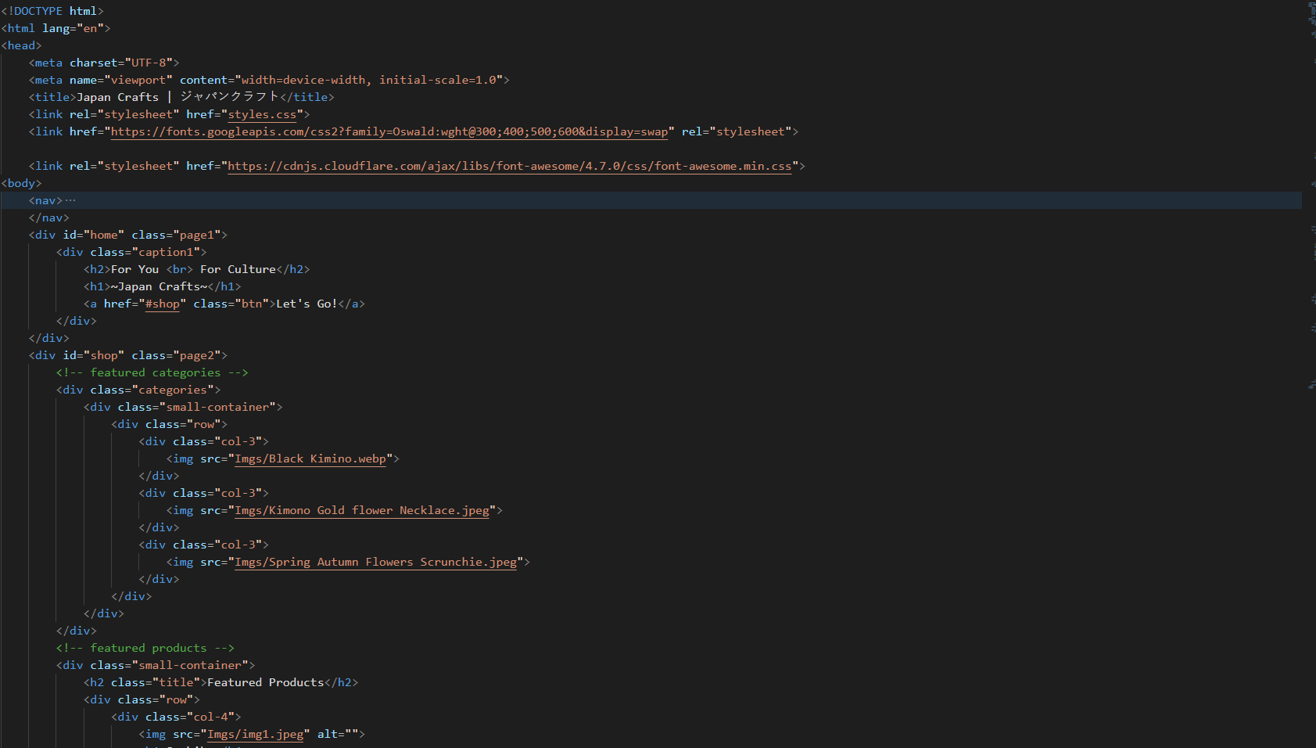

* CSS

Total more than 450+ lines are used for the website creation.

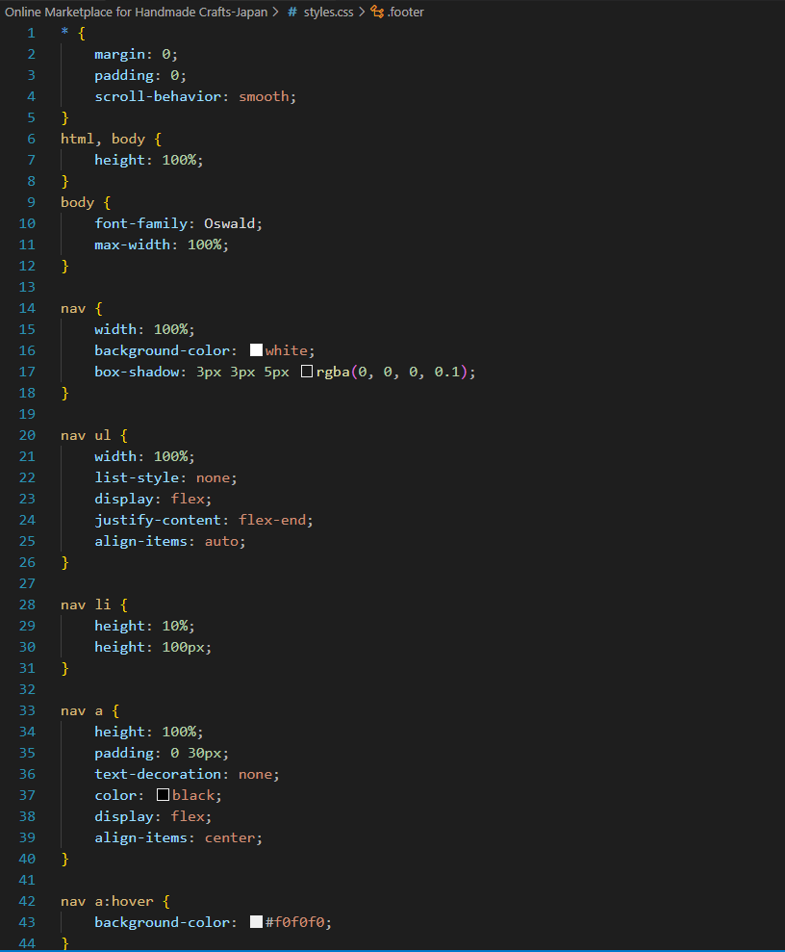

* JavaScript

Interesting fact to know that we used JavaScript in our website for nav bar for mobile users to use our website appropriately.

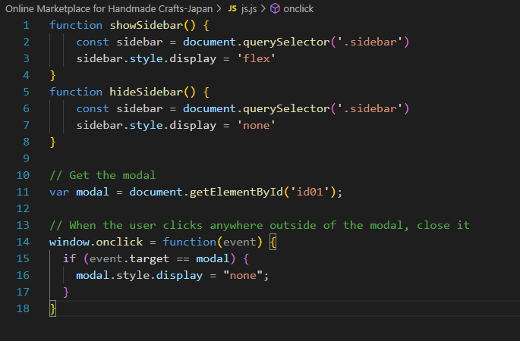

4. CONCLUSION

Through the course of this project, we have witnessed the power of technology in empowering artisans to showcase their skills and reach a global audience. The online marketplace serves as a virtual storefront, breaking down

geographical barriers and allowing crafters to connect with buyers who appreciate the value of handmade, artisanal products.

One of the key achievements of this project is the establishment of a user-friendly platform that facilitates seamless transactions, ensures secure payments, and provides a personalized shopping experience. The features implemented, such as user profiles, product categorization, and a robust search functionality, contribute to an engaging and efficient online shopping environment.

5. REFERENCES

* CSS
* HTML5
* JavaScript
* Visual Studio Code

6. ACKNOWLEDGMENT

We would like to express our gratitude towards **Mr. Muhammad Rafeeq War** for his support in accomplishment of our project on Online Market place for Handmade Crafts.

I would like to extend my deep appreciation to all my group members, without their support and coordination we would not have been able to complete this project.

Group 8 from K23FS

28th November 2023

* HOME PAGE

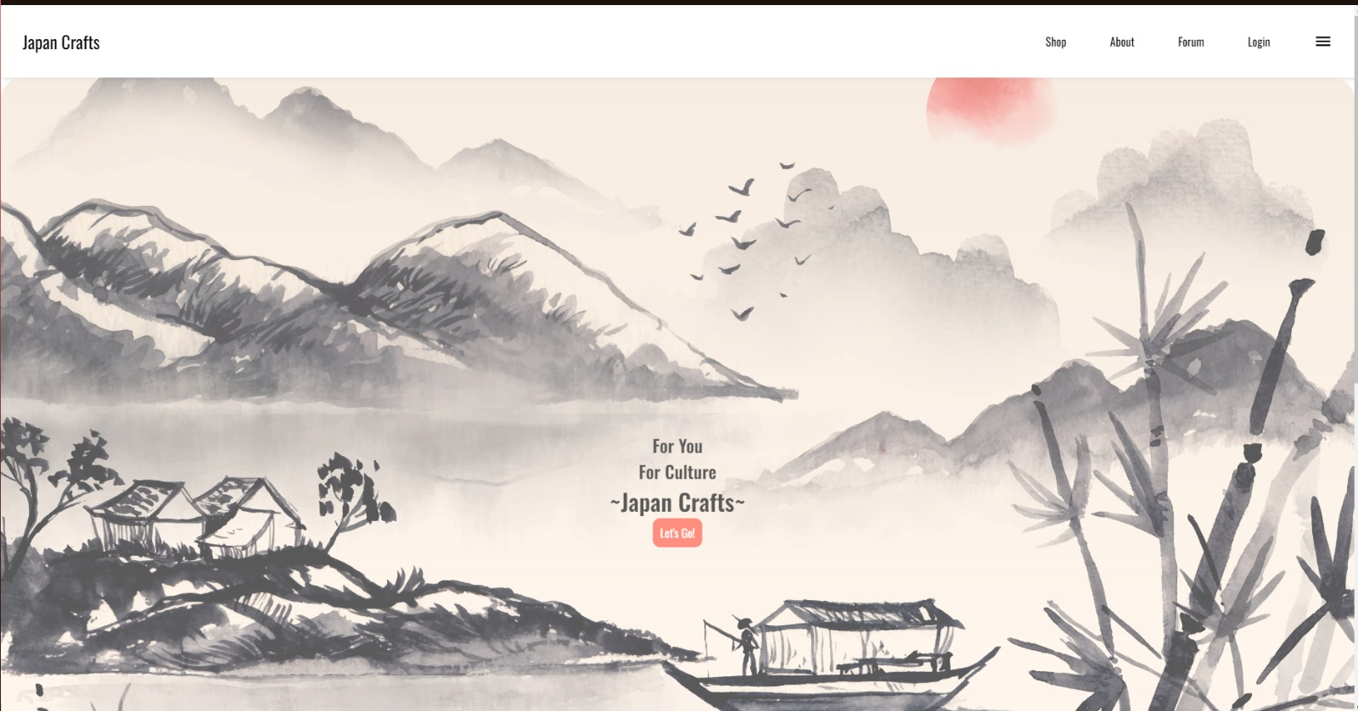

* Navigation Bar

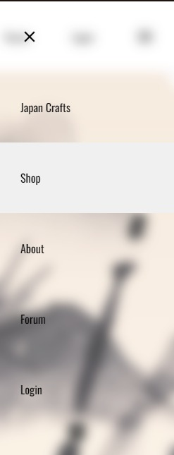

* Featured Categories (Will zoom when hovered)

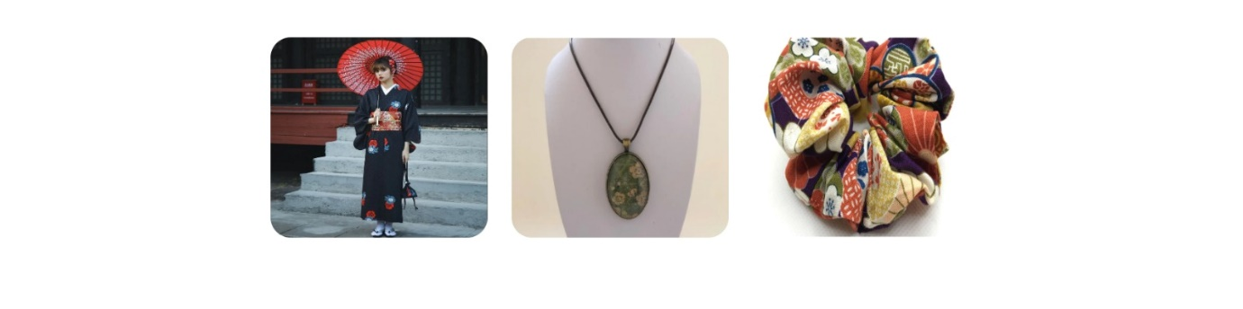

* Featured Products (When hovered over image will zoom in)

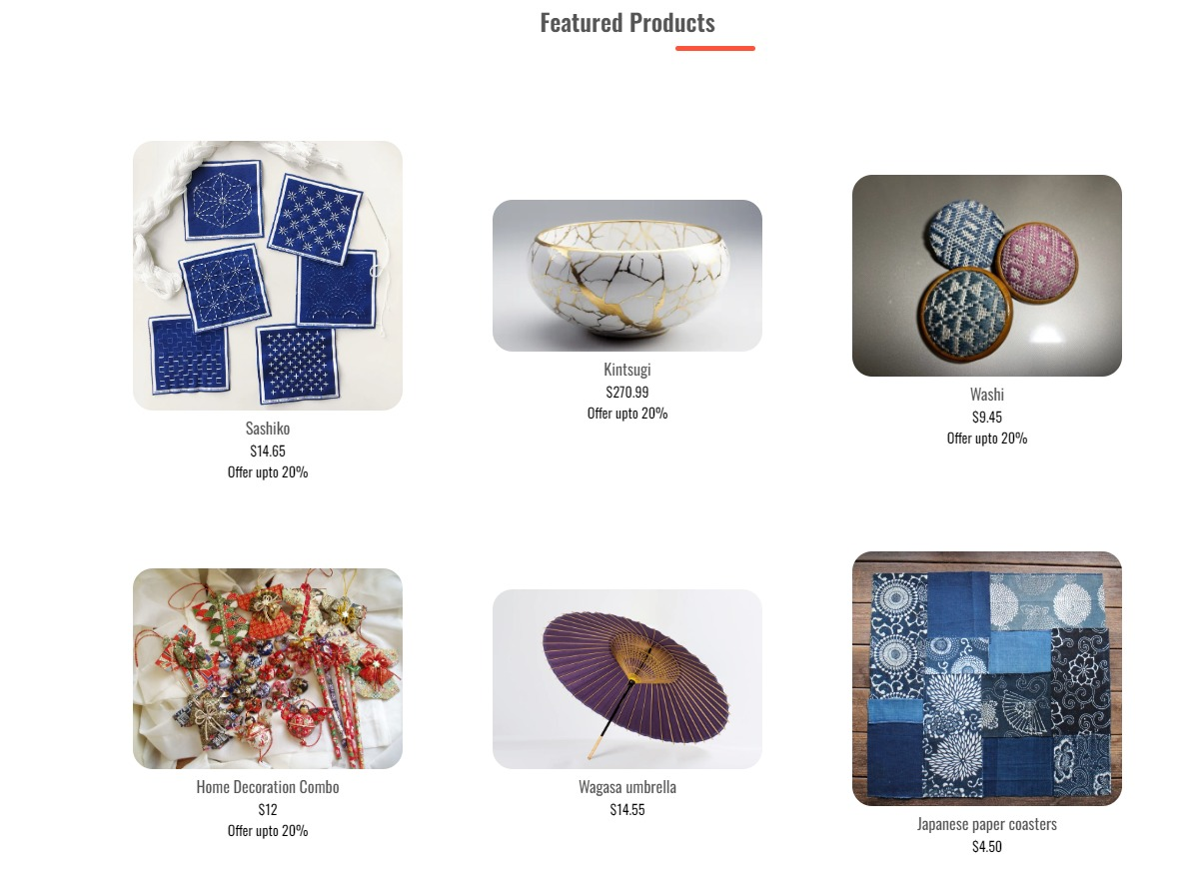

* Exclusive Product (Lighting Offer)

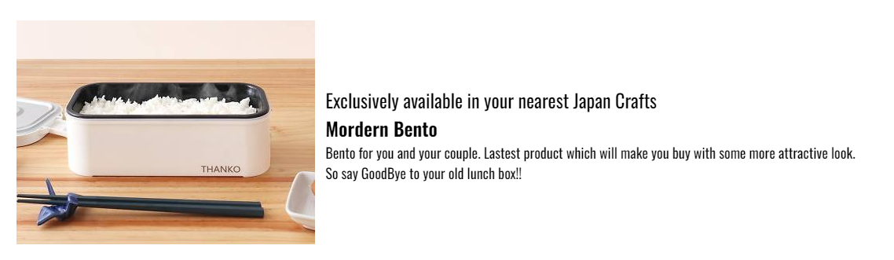

* Our Forum Page (FAQ’s)

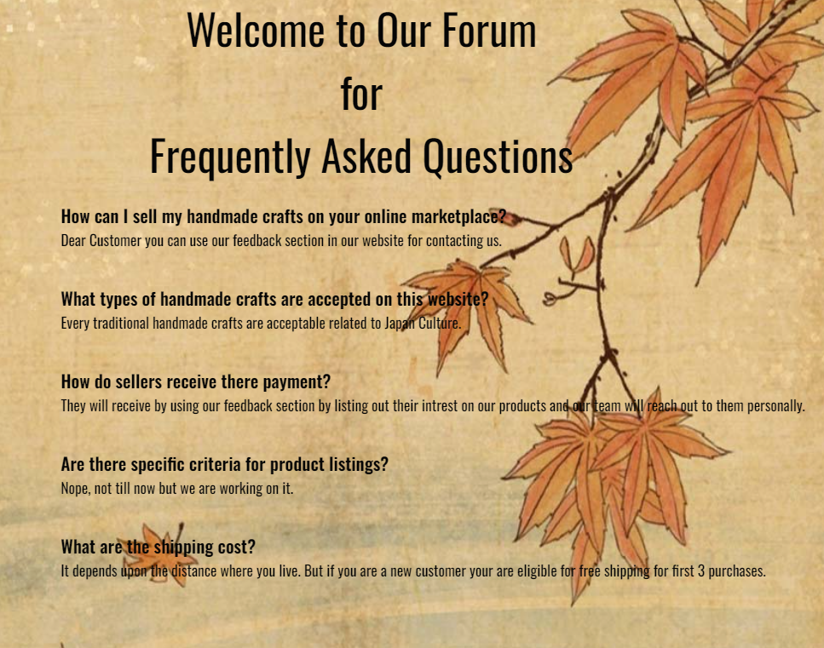

* Feedback Page

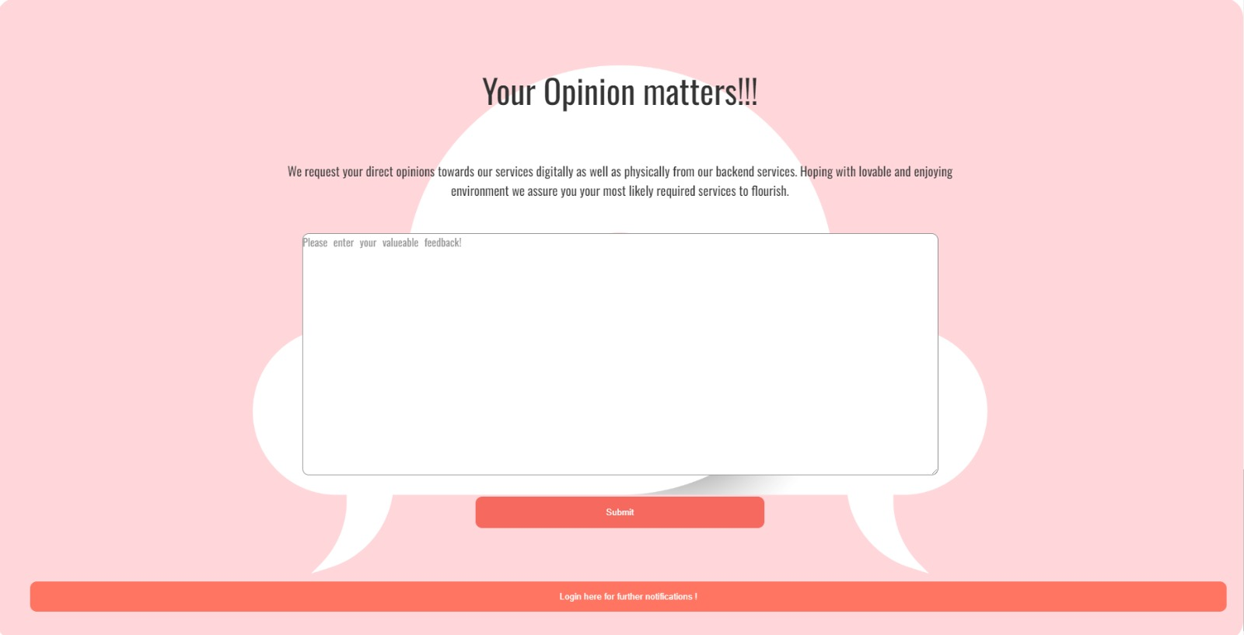

* About Team

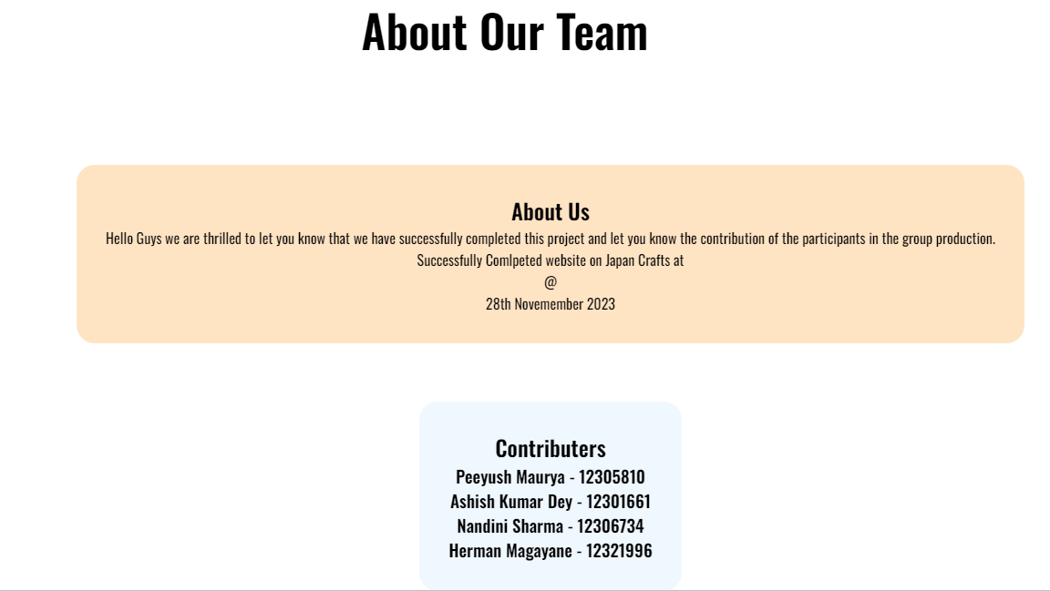

* Footer

